Unsupervised Learning and Clustering Analysis Report
New York City Airbnb Open Data (2019)
Virtual Data Science with Python Trainee — Week 3 Task

1. Introduction
This report applies unsupervised learning, specifically K-Means clustering, to the cleaned New York City Airbnb Open Data (2019) dataset (48,870 listings) produced in Week 1. The objective is to segment listings into meaningful groups based on pricing and demand behavior, without using any predefined labels, and to interpret the business meaning of each resulting cluster. Python's scikit-learn library was used to implement the clustering pipeline, alongside pandas, matplotlib, and seaborn for preprocessing and visualization.

2. Methodology
Clustering requires selecting features that describe listing behavior in a comparable way. Five numeric features were chosen to capture price, minimum stay requirements, and demand signals:
- price_capped — nightly price (outlier-capped in Week 1)
- minimum_nights — minimum length of stay required
- number_of_reviews — total review count (a proxy for cumulative demand)
- reviews_per_month — review velocity (a proxy for recent/ongoing demand)
- availability_365 — days available for booking per year
Since K-Means is a distance-based algorithm, all features were standardized (zero mean, unit variance) using scikit-learn's StandardScaler before clustering. This prevents features on larger numeric scales, such as availability_365, from dominating the distance calculation over features on smaller scales, such as reviews_per_month.
from sklearn.preprocessing import StandardScaler
from sklearn.cluster import KMeans
features = ["price_capped", "minimum_nights", "number_of_reviews",
"reviews_per_month", "availability_365"]
X = df[features]
scaler = StandardScaler()
X_scaled = scaler.fit_transform(X)

3. Choosing the Number of Clusters
Two standard techniques were used together to select k: the elbow method (inertia, or within-cluster sum of squares, versus k) and the silhouette score (a measure of how well-separated clusters are, ranging from -1 to 1).
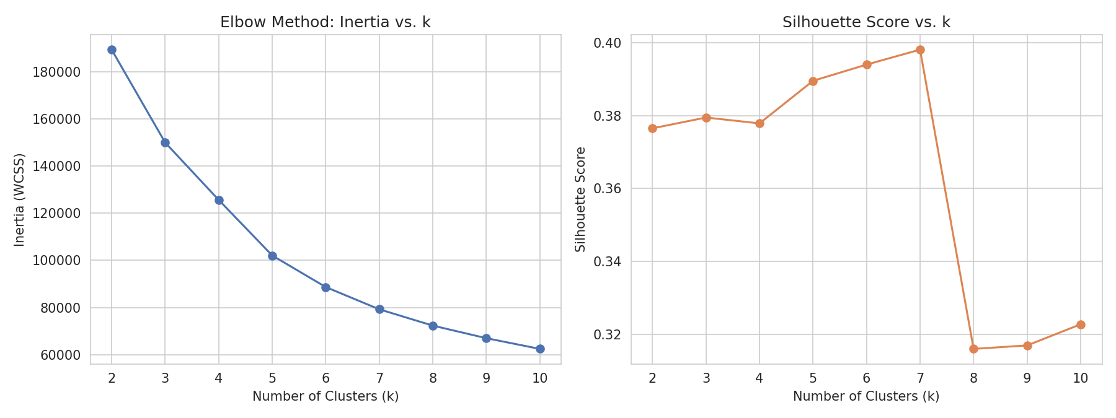
Figure 1. Elbow method (left) and silhouette score (right) across k = 2 to 10.
Inertia decreases steadily as k increases, without a single sharp 'elbow,' which is common with real-world behavioral data. Silhouette scores stay in a similar range (0.32–0.40) across most values of k, peaking slightly at k=7 (0.398). Given that the silhouette differences across k=4 through k=7 are small, k=4 was selected as the final model: it produces the most interpretable, business-meaningful segments while still achieving a comparable silhouette score (0.378) to higher values of k.
from sklearn.metrics import silhouette_score
for k in range(2, 11):
km = KMeans(n_clusters=k, random_state=42, n_init=10)
labels = km.fit_predict(X_scaled)
print(k, silhouette_score(X_scaled, labels))

4. Clustering Results
K-Means was fit with k=4 on the standardized features. The resulting silhouette score of 0.378 indicates reasonably well-separated, though not perfectly distinct, clusters — expected given that pricing and demand behavior exist on a continuum rather than in fully separable groups. Principal Component Analysis (PCA) was used to reduce the five features to two dimensions for visualization, capturing 58.4% of total variance.
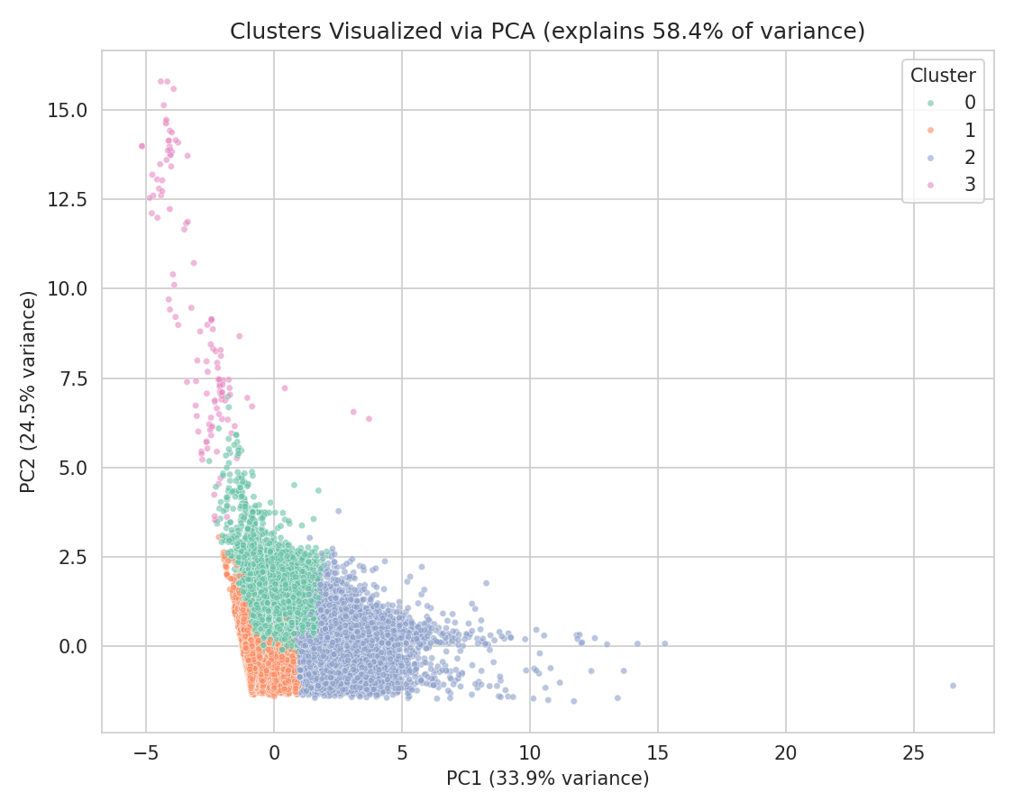
Figure 2. Clusters visualized in 2D PCA space.
The PCA plot shows Cluster 3 (pink) forming a distinct, separated group along PC2, while Clusters 0, 1, and 2 sit along a continuum in PC1 — consistent with them representing gradations of similar underlying behavior (e.g., price and availability) rather than fully independent categories.

5. Cluster Profiles
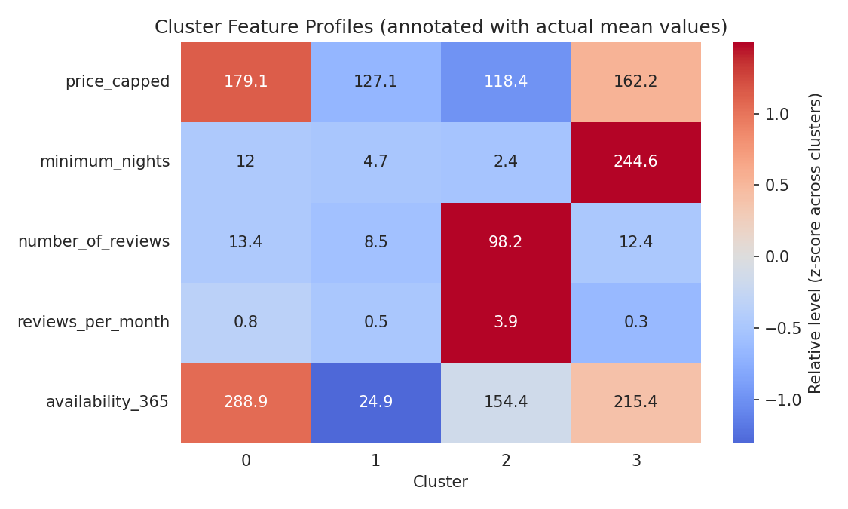
Figure 3. Cluster feature profiles, colored by relative level (z-score) and annotated with actual mean values.
Based on the mean feature values per cluster, four distinct listing segments emerge:
- Cluster 0 — "High-Availability Premium Listings" (25.7%, 12,569 listings): highest availability (289 days/year) combined with high price ($179) and low review velocity. These behave like professionally managed listings kept open year-round, priced at a premium, without depending on high review turnover.
- Cluster 1 — "Standard Low-Availability Listings" (59.0%, 28,828 listings): the largest segment, with low availability (25 days/year), moderate price ($127), and modest review activity. These likely represent typical hosts renting occasionally, such as a spare room rented only part of the year.
- Cluster 2 — "High-Demand Frequently-Reviewed Listings" (15.0%, 7,350 listings): by far the highest review count (98) and review velocity (3.92/month), with the lowest minimum stay (2.4 nights) and moderate price ($118). These are highly active, frequently turned-over short-stay listings — likely top-performing hosts optimized for volume.
- Cluster 3 — "Long-Minimum-Stay Listings" (0.3%, 123 listings): a small but distinctive group defined by an extreme minimum stay requirement (245 nights on average), high price ($162), and very low review activity. These resemble medium/long-term corporate or extended-stay rentals rather than typical short-term tourist listings.

6. Cluster Composition by Room Type and Borough
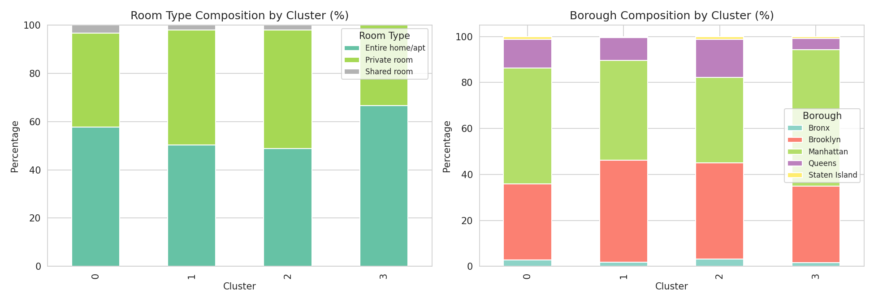
Figure 4. Room type (left) and borough (right) composition within each cluster.
Cluster 2 (high-demand, frequently reviewed) skews more heavily toward private rooms than the other clusters, consistent with budget-conscious, frequently turned-over stays. Cluster 0 (high-availability premium) has the highest share of entire home/apt listings, consistent with professionally managed properties. Borough composition is broadly similar across clusters, though Cluster 3 (long-minimum-stay) shows a higher relative share of Manhattan listings, consistent with corporate extended-stay demand concentrating in the borough with the most business activity.

7. Geographic Distribution of Clusters
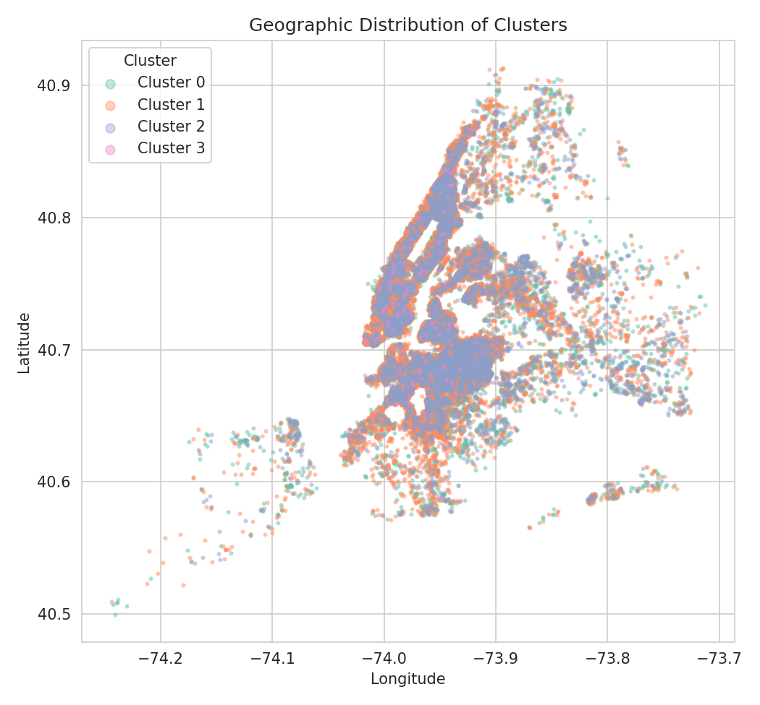
Figure 5. Geographic distribution of listings, colored by cluster assignment.
Clusters 0, 1, and 2 are distributed across all five boroughs in broadly similar spatial patterns, following the overall density of Airbnb listings citywide (concentrated in Manhattan and Brooklyn). This indicates that a listing's cluster membership is driven primarily by its pricing and demand behavior rather than by its specific location.

8. Discussion and Business Implications
These four clusters translate into distinct implications for hosts, platform operators, and market analysts. Cluster 1, the largest group at 59% of listings, represents the 'typical' occasional host and is the most price-sensitive segment to target for engagement or upgrade campaigns. Cluster 2's high review velocity at a moderate price point suggests these are the most competitively positioned listings in the market — a benchmark segment for pricing strategy. Cluster 0's combination of high price and high availability without high review turnover suggests professional management rather than organic demand, which may warrant different marketing treatment than owner-occupied listings. Cluster 3, while small, is business-relevant precisely because of its rarity: identifying long-minimum-stay listings separately allows the platform to treat them differently from typical short-term rental supply in inventory or pricing algorithms.
A limitation worth noting: K-Means assumes roughly spherical, similarly-sized clusters in the feature space, which may not perfectly reflect the true underlying structure of this data (as suggested by the continuum seen in the PCA plot for Clusters 0–2). Hierarchical clustering or DBSCAN could be explored in future work to check whether a non-spherical or density-based approach reveals additional structure, particularly for separating Cluster 0 from Cluster 1 more cleanly.

9. Conclusion
This task applied K-Means clustering to the NYC Airbnb dataset, using the elbow method and silhouette score to select k=4 as a balance between statistical separation and interpretability. The resulting four clusters — high-availability premium listings, standard low-availability listings, high-demand frequently-reviewed listings, and long-minimum-stay listings — represent meaningfully different segments of the short-term rental market, each with distinct pricing, availability, and demand characteristics that could inform targeted host support, pricing benchmarks, or inventory classification in future analysis.

